|  |
| --- |
|  |
| 新概念 3 册 |
| Lesson48 |

Lesson 48 The silent village

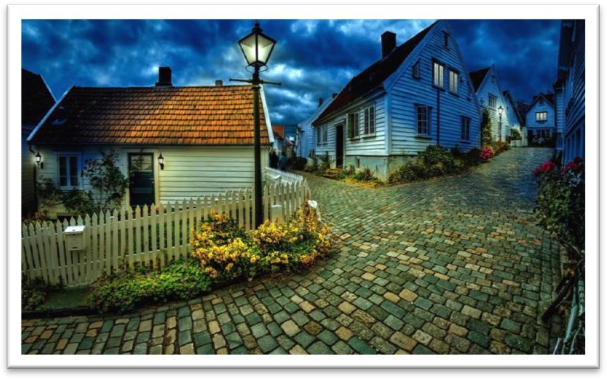

**inaccessible [ɪnək'sesəbl]**

**adj. 无法到达的**

The country consists mainly of dense jungles and inaccessible mountain ranges.

The bathroom is situated at the top of a flight of stairs, making it inaccessible *to* the disabled. accessible

The village is isolated and accessible only by helicopter. All parts of the museum are accessible *to* wheelchairs. access n. 1.（接近或进入某地的）方法，通道

access to …

The only access to the farmhouse is across the fields. access n. 2.（使用某物或接近某人的）机会或权利have access to …

Students must have access to a good library. Only high officials have access to the president. **hospitable ['hɒspɪtəbl]**

adj. 好客的

be hospitable to / towards sb.

The local people are very hospitable to strangers. hospitality

Thank you for your kind hospitality.

The Chinese are noted for their hospitality. inhospitable unfriendly

unwelcoming forbidding a forbidding place / appearance

The more expensive kind of antique shop where rare objects are beautifully displayed in glass cases to keep them free from dust is usually a forbidding place.

hostile ['hɒstaɪl] ['hɑ:stl]

**adj. 很不友好的，有敌意的**

hostile attitude

a hostile response / reaction / crowd / review / reception … be hostile to / towards ...

But people who are cut off not only from foreign tourists, but even from their own countrymen can be hostile to travellers.

be antagonistic to / towards ...

He's always antagonistic towards new ideas. hostile docile

fertile fragile

futile infantile

juvenile missile

mobile reptile

vicinity [vɪ'sɪnɪti]

**n. 附近地区**

in the vicinity (of sth.)

There is no hospital in the vicinity.

There are several hotels in the immediate vicinity of the station.

We had spent several days in a small town and visited a number of old churches in the vicinity. Everyone knows that if he shouts in the vicinity of a wall or a mountainside, an echo will come back.

in the neighborhood (of sth.)

Is there a good Chinese restaurant in the neighborhood? Houses in the neighborhood of Paris are extremely expensive.

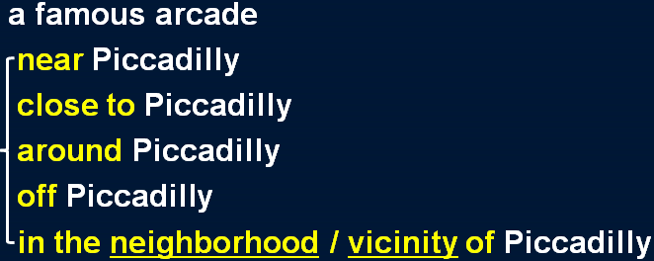Hans returned to his family home, but the house had been bombed and no one in the neighbourhood knew what had become of the inhabitants.

only a short bus ride away within walking distance within driving distance within commuting distance only a stone’s throw away **abruptly [ə'brʌptlɪ]**

adv. 突然地，意外地

abrupt adj. 1. sudden and unexpected, often in an unpleasant way 突如其来的，意外的

an abrupt ending / change / departure

come to an abrupt end / halt The bus came to an abrupt halt.

Our friendship came to an abrupt end. bring sth. to an abrupt end / halt

The accident brought his career to an abrupt end.

abrupt adj. 2. seeming rude and unfriendly, esp. because you do not waste time in friendly conversation 粗鲁无礼的，无耐心的

an abrupt manner

She was very abrupt with me in our meeting. abruptly

The interview ended abruptly.

‘Good night, then,’ she said abruptly.

tramp [træmp]

**v. 缓慢而步履沉重地行走**

tramp v. to walk somewhere slowly and with heavy steps 缓慢而步履沉重地行走

He tramped the streets looking for work. tramp through / across / around …

We tramped through the wood for over two hours until we arrived at a deep stream. go for a solitary tramp in the country

We had a long tramp home.

But real tramps are not beggars.

dilapidated [dɪ'læpɪdeɪtɪd] adj. 破旧的，年久失修的

dilapidated adj. (of furniture and buildings) old and in very bad condition 破旧的，年久失修的

a dilapidated chair / bed

We stayed in an old, dilapidated hotel with a leaky roof. battered adj. old, used a lot, and in bad condition 破旧不堪的a battered old suitcase

a battered old car

While the battered car was moving away, Roy stopped his bus and telephoned the police. rickety adj. a rickety structure or piece of furniture is in very bad condition, and likely to break easily 摇摇晃晃快散架的

a rickety old wooden chair

When lights fuse, furniture gets rickety, pipes get clogged, or vacuum cleaners fail to operate, some women assume that their husbands will somehow put things right.

rag [ræg]

**n. 破布，碎布片**

in rags

a tramp dressed in rags

Children in rags begged money from the tourists. from rags to riches

He likes to tell people of his rise from rags to riches. costume overalls / coveralls

uniform school / military uniform sportswear leisure wear

underclothes underwear

suit shroud

procession [prə'seʃn] n.（人或车）队伍

procession n. a line of people or vehicles that move along slowly, especially as part of a ceremony

（人或车）队伍

a funeral / wedding / carnival procession march in procession

Groups of unemployed people from all over the country marched in procession to the capital. There seemed to be an endless procession of boyfriends knocking on her door.

parade n.（节日或庆典）游行的队伍；阅兵式；列队展示或表演a victory / carnival parade

a military parade a fashion parade

a parade of players before a football match

She had a constant parade of young men coming to visit her.

column n. a long moving line of people or things（人或事物的）队伍a column of soldiers

a column of refugees

Who has not stood in awe at the sight of a spider pouncing on a fly, or a column of ants triumphantly bearing home an enormous dead beetle?

**peer [pɪə(r)] v.（因看不清而）仔细看**Mary peered at her watch.

He peered closely at the photograph.

Old women in black shawls peered at us from doorways. squint at … squint one’s eyes

Stop squinting at the screen ― put your glasses on.

Then, squinting his eyes, he said: 'The light is dim. Read the letter to me.' peer at … peep / peek at …

leer at …

He was always leering at female members of staff. glance at … glimpse …

peep / peek at … leer at …

He was always leering at female members of staff. glance at … glimpse …

gaze at … stare at … gape at … glare at …

much-travelled

much-loved much-respected much-admired much-discussed much-criticized much-acclaimed

Up to now, historians have assumed that calendars came into being with the advent of agriculture, for then man was faced with a real need to understand something about the seasons. When lights fuse, furniture gets rickety, pipes get clogged, or vacuum cleaners fail to operate, some women assume that their husbands will somehow put things right.

But people who are cut off not only from foreign tourists, but even from their own countrymen can be hostile to travellers.

cut … off from ... to prevent sb./sth. from leaving or reaching a place or communicating with people outside a place 使……与……隔绝

Having a new baby can cut a young mother off from the adult world. Accessible only by air, the town is cut off from the rest of the country.

Except for one or two places such as Zermatt and Chamonix, which had rapidly become popular, Alpine villages tended to be impoverished settlements cut off from civilization by the high mountains.

be out of touch with ... 与……失去联系，不了解…… We've been out of touch with Roger for years now.

Old people sometimes are out of touch with the modern world. separate … from … 把……与……隔离

Separating prisoners from each other is sometimes the only way of preventing riots.

After having been wounded towards the end of the war, he had been sent to hospital and was separated from his unit.

isolate … from ... 把……与……隔离

A high wall isolated the house from the rest of the village.

When a person has an infectious disease, he is usually isolated from other people. segregate … from …（因种族，性别，宗教等原因）把……与……隔离

a culture in which women are segregated from men Blacks were segregated from whites in schools. one’s (fellow) countryman

= one’s compatriot

a hero much loved by his countrymen

Didn’t he feel guilty about betraying his fellow countrymen?

Chris Robertson of Australia beat his compatriot Chris Dittmar in the final. one’s fellow Chinese / Americans …

And so, my fellow Americans, ask not what your country can do for you; ask what you can do for your country.

— John F. Kennedy

Visits to really remote villages are seldom enjoyable ― as my wife and I discovered during a tour through the Balkans.

as 引导的非限定性定语从句与 which 引导的非限定性定语从句的区别。

1、as 作为关系代词指代整个主句，而 which 作为关系代词指代整个主句或先行词均可。

2、as 引导的非限定性定语从句位于主句前、中、后均可，而which 引导的非限定性定语从句不能位于主句之前。

As a poet points out, life is but a dream. Children, as is always the case, love their mother. She became angry, as many could see.

3、as 引导的非限定性定语从句含有“众所周知”的意思，常译为“正如……”，而which 引导的非限定性定语从句则未必有这个意思。

The sun heats the earth, which makes it possible for plants to grow.

4、在“as + is/was + done”结构中可省略“is/was”，而在 “which + is/was + done”可省略“which + is/was”，而不能只省略 be 动词。

As (is) reported, a foreign delegation will visit the city. a puma (which was) at large

Things can go wrong on a big scale, as a number of people recently discovered in Parramatta, a suburb of Sydney.

As the Commanding Officer explained later, one half of the station did not know what the other half was doing!

If, as has been reported, they have protected humans from sharks, it may have been because curiosity attracted them and because the scent of a possible meal attracted the sharks.

As is so often pointed out, knowledge is a two-edged weapon which can be used equally for good or evil.

These attracted many visitors, for they were not only of great architectural interest, but contained a large number of beautifully preserved frescoes as well.

of + 名词 : 描述人或事物的特征

**1、做后置定语。**

**2、在系动词后做表语。**

Nothing of value was found, but the numerous items which were brought to the surface proved to be of great interest.

Nothing valuable was found, but the numerous items which were brought to the surface proved to be very interesting.

These attracted many visitors, for they were not only of great architectural interest, … These attracted many visitors, for they were not only architecturally interesting, ... The museum contains a number of original artworks.

The room was small and contained far too much furniture. beautifully adv. 1. in a beautiful way 美丽地，漂亮地They had large rooms with beautifully decorated walls.

Diamond necklaces and rings had been beautifully arranged on a background of black velvet. beautifully adv. 2. very well 很好地

My leg has healed beautifully. The children behaved beautifully.

Imagine their dismay when they found a beautifully-cooked wallet and notes turned to ash!

造句：故宫 (the Imperial Palace) 吸引了很多游客，因为它不但在建筑方面很有趣，而且里

面有大量的保存完好的文物 (historical relic)。

The Imperial Palace attracts many visitors, for it is not only of great architectural interest, but contains a large number of beautifully preserved historical relics as well.

On the day before our departure, several bus loads of tourists descended on the town. The day after the birth of the five children, an aeroplane arrived in Aberdeen bringing sixty reporters and photographers.

We met on the following day. We met the following day.

We met in the spring of 1983. We met the spring of 1983.

a truck load of wood a ship load of cotton a car load of visitors

descend on / upon ... 1. to visit sb./sth. in large numbers, esp. unexpectedly or inconveniently 大批突然到来

Millions of tourists descend upon the area every year. Crowds of tourists descended on the tiny church.

descend on / upon 2. (of night, darkness, a mood, etc.) to arrive and begin to affect sb./sth.,

esp. suddenly （黑暗，夜色，某种情绪等）突然降临

Total silence descended on the room. Calm descended upon the crowd.

Few things could be more impressive than the peace that descends on deserted city streets at weekends when the thousands that travel to work every day are tucked away in their homes in the country.

be more than … can / could ...

Dancing proved to be more than the dish could bear, for during the party it capsized and sank in seven feet of water.

The pain is more than I can bear. The story is more than I can believe.

The beauty of the West Lake is more than words can describe.

Such a complicated situation is far more than we could anticipate and deal with.

Taking a path which led out of the town, we crossed a few fields *until we came to a dense wood*. take v. use (a road, path, etc) as a route to go to a place 取道……

I usually take the M6 when I go to Scotland.

lead v. to go in a particular direction or to a particular place 通往…… The path led down to a small lake.

This door leads into the garden.

We followed a dirt track leading through the woods. The road leads west for three miles, then turns south. trace / weave / wind one’s way

Highway 99 winds its way along the coast.

Lori spotted them as they weaved their way through the tables.

have no idea / not have any idea *that / how / what / why / which / where …*

He had no idea *(that) she was like that*.

She doesn't have any idea *where they've gone*.

They had no idea *what time they were supposed to arrive*. moor v. 停泊

We moored alongside the quay. moor … to …

We moored the boat to a large tree root.

A number of fishing boats were moored to the quay. anchor v. 抛锚，停泊

They anchored the ship in the harbor. The ship anchored in the harbor.

Before she had anchored, the men from the boats had climbed on board and … cast / drop anchor

weigh anchor / set sail

We dropped anchor a few yards offshore.

The next morning, they weighed anchor and began to move south again. In it there was a boatman who was fast asleep.

be fast / sound asleep

be sleeping deeply / soundly / tight ferry n. 渡船；渡口

ferry v. to carry people or goods between two or more places 运送（人或货物）

ferry goods to the mainland Can you ferry us across?

be reluctant / unwilling to do sth. persuade sb. to do / into doing sth.

The path led to a tiny village perched on the steep sides of a mountain. be perched on …

For one agonizing moment, the dish was perched precariously on the bank of the canal, but it suddenly overbalanced and slid back into the water.

a house perched on a cliff above the town

The place consisted of a straggling unmade road which was lined on either side by small houses. straggle v. grow or spread in an irregular or untidy manner 无规则地或散乱地生长或散布Unpainted wooden buildings straggle along the main road out of town.

a straggling village

vines straggling over the fences winding tortuous

The road is tortuous, but the prospects are bright. line v. form a line along sth. 沿某物排成行

Tall trees line the road on either side.

The road is lined with / by tall trees on either side.

*Even under a clear blue sky*, the village looked forbidding, as all the houses were built of grey mud bricks.

The village seemed deserted, the only sign of life being an ugly-looking black goat *on a short*

*length of rope tied to a tree in a field nearby*. a very modern-looking woman

an interesting-looking carved dagger the sorry-looking, blackened figure an ugly-looking black goat

Please keep your dog on a leash.

Each of the four cables contains 26,108 lengths of wire.

She kept it tied to a tree in a field during the day and went to fetch it every evening.

The student hid in an archway nearby where he could watch and hear everything that went on. The village seemed deserted, and the only sign of life was an ugly-looking black goat on a short length of rope tied to a tree in a field nearby.

造句：这本书很无聊 (boring)，唯一有趣的部分是它的封皮。The book is boring, the only interesting part being its cover.

造句：箱子 (chest) 里的东西 (contents) 令人失望，唯一有价值的发现是一柄看起来有趣的雕花的匕首。

The contents of the chest were disappointing, the only valuable find being an interesting-looking carved dagger.

Sitting down on a dilapidated wooden fence near the field, we opened a couple of tins of sardines and had a picnic lunch.

all at once suddenly

all of a sudden

alarm n. a feeling of fear or worry because sth. bad or dangerous might happen 惊慌，恐慌

She looked up in alarm.

Scientists have said there is no cause for alarm.

be filled with anger / fear / dread / horror / joy / happiness / doubt / alarm / revulsion / admiration / remorse …

Their faces were suddenly filled with fear.

I am filled with admiration for your bravery.

Knowing that the industrious ant lives in a highly organized society does nothing to prevent us from being filled with revulsion when we find hordes of them crawling over a carefully prepared picnic lunch.

Looking up I saw that we were surrounded by children in rags *who were looking at us silently as we ate*.

offer sb. sth. offer sth. to sb.

be shy of … 对……腼腆羞怯；害怕……

Children are often shy of people they don't know. I'm shy of buying shares, in case I lose money.

Once bitten, twice shy. a nice *cup* of tea

a beautiful *stretch* of field a stagnant *pool* of water

For most of them, 50 pence is a small price to pay for a nice big *bar* of chocolate. Our next obstacle was a shallow *pool* of water about half a mile across.

When we later walked down the main street of the village, we were followed by a silent

*procession* of children.

come to life to become more interesting, exciting or full of activity 变活跃起来

The match finally came to life in the second half.

You're very cool with your brother, but with your friends you really come to life. She smiled.

A smile appeared on her lips. Her lips curved into a smile.

Her rosy lips curved into a gentle smile.

in shirt sleeves / shirt-sleeves: dressed informally without wearing anything, such as a jacket, over a shirt 只穿衬衣的

there is no doubt / question that ...

There is no doubt that if she had not lost her rudder she would have won the race easily. There is no question that the government knew about the deal.

Turning back down the main street, we quickened our pace and made our way rapidly towards the stream *where we hoped the boatman was waiting*.

quicken one’s pace

He quickened his pace, longing to be home.

Thinking that she was being followed, she quickened her pace. make one’s way 前往某地

I made my way *to the house*.

I made my way *into the backyard*. I made my way *along the river*.

I made my way *up the stairs*.

The hospital had been bombed and Hans had made his way back *into Western Germany* on foot. Turning back down the main street, we quickened our pace and made our way rapidly *towards the stream* where we hoped the boatman was waiting.

嵌入式定语从句 (Embedded Attributive Clause)

这种定语从句的特征是：既修饰先行词又同时做另一个主谓结构的宾语。

She has an adopted son who *she says* is an orphan.

Aleko suddenly acquired a new lamb which *he claimed* was bought.

In this part of the cave, they could hear an insistent booming sound which *they found* was caused by a small waterspout shooting down into a pool from the roof of the cave.

Turning back down the main street, we quickened our pace and made our way rapidly towards the stream, *and* we hoped that the boatman was waiting *there*.